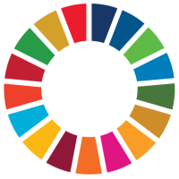
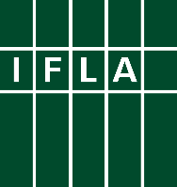
Libraries Engaged in VNRs
Part 2: Prepare your Stories

Voluntary National Reviews (VNRs) can be a great way for libraries to engage in discussions around the implementation of the Sustainable Development Goals (SDGs), and to be recognised for their contributions. This series offers ideas for key actions libraries and library associations can take to get involved.

The second step towards engagement in a Voluntary National Review is to prepare materials that you can use in your advocacy. A key ingredient of this is stories which explain how, in human terms, libraries deliver development.

These are likely to be popular with governments. In previous reports, countries have used examples to demonstrate how they are helping to achieve the Sustainable Development Goals on the ground, for example in inset boxes. A good objective is therefore to get at least one example of the work of libraries referenced in reporting.

Firstly, you should look to understand what subjects your country’s VNR may focus on. At HLPF 2022, there will be a particular focus on SDGs 4 (quality education), 5 (gender equality), 14 (life under water), 15 (life on land) and 17 (partnerships for the goals), under the broader theme: Building back better from the coronavirus disease (COVID-19) while advancing the full implementation of the 2030 Agenda for Sustainable Development. As such, your government may want to focus on these in particular.

It may also depend on who the coordinating ministry or agency is in your country. If it is the environment ministry, they may tend to talk more about environmental sustainability. If they are from the planning ministry, they may be more interested in local and regional development.

Secondly, you should start to collect stories. To do this, you can take inspiration from IFLA’s own SDG Stories, or the great examples that have been collected by library associations around the world. Do any of them sound like things that libraries in your country are doing? When collecting and writing stories down, try to make them real, to explain the unique contribution of libraries, to provide evidence of impact (either numbers, or feedback from those who benefitted),

There’s lots more advice in IFLA’s Storytelling Manual. If one or more of your stories fulfils the conditions in the Manual – set out more simply in our SDG Storytelling Flowchart – you should feel ready to submit it as an SDG Story to the Library Map of the World. This will mean that library advocates elsewhere in the world can draw on your examples in their own work!

Good luck, and let us know how you’re getting on!

