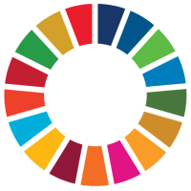
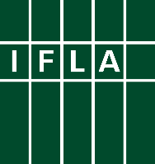
Libraries Engaged in VNRs
Part 7: Communicate to the Public Partners

Voluntary National Reviews (VNRs) can be a great way for libraries to engage in discussions around the implementation of the Sustainable Development Goals (SDGs), and to be recognised for their contributions. This series offers ideas for key actions libraries and library associations can take to get involved.

The seventh step towards engagement in a Voluntary National Review (VNR) is to communicate to the public. This can not only increase the pressure on the government to incorporate your contributions and messages, but also help build support for libraries more generally.

The United Nations itself has placed a very strong focus on public communication and engagement around the Sustainable Development Goals and the wider 2030 Agenda. This is partly because achieving them will take the efforts and contributions of everyone, and partly because greater public awareness will also mean that those in power need to explain what they are doing – or have done – to deliver.

This is particularly the case in countries which are undertaking Voluntary National Reviews. By being active, you can take advantage of the broader attention to the SDGs, and in doing so, build a broader sense of how libraries are central to sustainable development across the board. You can also, in turn, support the UN’s work to raise awareness of the SDGs!

To do this effectively, you should think both about the means and the message. Concerning the means, you will know best what works in your local context to get the message out. In addition to direct action – social media, letters to newspapers or calls to TV or radio shows, think about whether you can contact journalists or influencers who have a wider reach – don’t forget that your message may be more powerful coming through someone else. Try those who are already interested in education, culture, research or simply who have a soft spot for libraries!

The message is equally important. Just as in preparing your materials for decision-makers, you will need to define a small number of powerful messages, and present them attractively. You should assume that both journalists, and the public, are busy and will only pay attention if you manage to ‘hook’ them. Of course, if using social media, you also only have a limited space to make your point.

As far as you can, make sure to tell a human story, and ideally photographs – the examples on the Library Map of the World SDG Stories site provide a powerful example.

Good luck!

