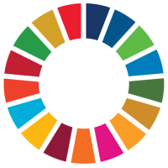
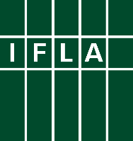
Libraries Engaged in VNRs
Part 8 Prepare for the High-Level Political Forum

Voluntary National Reviews (VNRs) can be a great way for libraries to engage in discussions around the implementation of the Sustainable Development Goals (SDGs), and to be recognised for their contributions. This series offers ideas for key actions libraries and library associations can take to get involved.

The eighth step towards successful engagement in a Voluntary National Review (VNR) is to prepare for the High-Level Political Forum at which Reviews will be presented. There is still plenty of uncertainty about how things will work in 2022, and whether in-person participation will be possible. However, after two years of practice, opportunities for online participation have been improved, meaning more people can join more easily.

Over three days – 13-15 July – Member States will present their reviews, either on their own or as part of a panel. Key messages (and full reports, most of the time) will be shared in advance – see this page, and filter the list by “2022” and “Voluntary National Reviews”). When you then click on the name of your country, you will be taken to a page showing these messages, as well as giving contact details and other useful background.

It will be useful to take a little time to read what your government has submitted, and to see how library priorities – and of course your own inputs – have been reflected. It is unlikely that libraries will be mentioned explicitly in the key points (although this should be a long-term goal!), but key themes such as education, literacy, culture, research, social cohesion and civic participation are all relevant areas.

First of all, you should try to find points where you can agree with the assessment the government has made and congratulate them on these either through direct contacts (e-mail or otherwise) or publicly. The team who has produced this may well continue to work on the SDGs, and it will be good to reinforce your contacts with them for the future.

Secondly, you should also look out for things you would want to change or add. In previous parts of this series, you have developed key messages and supporting arguments, data and stories. You can either highlight these (in a constructive way) on social media, or work through IFLA to help ensure that your concerns are reflected in the statements that will be made by the NGO Major Group during the High Level Political Forum itself. IFLA have tried to be in touch about how to be part of drafting teams.

Finally, IFLA will be sharing suggestions for letters that you can send to your governments in advance of the High-Level Political Forum, in order to ensure that the role of libraries is properly recognised in discussions.

Good luck!

