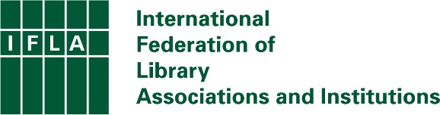

IFLA Statement on Open Library Data
Approved by the IFLA Governing Board, 15 December 2021

Data on levels of library provision and use can play an important role in supporting understanding, evaluation and planning at all levels. Without it, it is far harder to identify successes and needs, and to develop effective strategies for library development. It is also less easy to identify the contribution that libraries can make to the fulfilment of other policy goals.

IFLA’s Library Map of the World already provides a single portal on global library data, covering in particular data about numbers of libraries, library workers, libraries offering internet access, volunteers, loans (physical and electronic), and registered users and physical visits, broken down by library type.

Submitting data to the Library Map of the World not only increases the profile of libraries in a country, but allows for international analysis. However, library data collection and publication remains uneven from country to country. As well as limiting the ability of libraries in countries with lower library availability to benefit from the insights this information can bring, this also prevents cross-border comparisons that can provide a foundation for learning and exchange.

Data collection may be carried out by a variety of different actors, from national statistics authorities or ministries to library agencies and associations. Even where it does not collect such data directly, it is important that governments make resources available, where needed, to ensure the comprehensiveness of the data collected.

Such data, once collected and organised, should not be restricted to governments or other limited groups. Making data open and re-usable can help bring a wider range of actors into discussions about libraries, as well as encouraging research. Publishing data through the Library Map of the World allows for simple international comparisons.

In addition to aggregated numbers, disaggregation – for example by type of user, activities pursued at the library, local area – can offer important additional insights.

IFLA therefore recommends that governments or other relevant public bodies:

- Ensure the comprehensive collection of data about libraries and their use. This should cover at least the datasets included in IFLA’s Library Map of the World.

- Ensure that funding for such data collection, where required, is additional to existing library budgets and support.

- Ensure that such data is published in a timely manner, according to FAIR (free, accessible, interoperable, reusable) principles.

- Ensure that library data is submitted to the IFLA Library Map of the World.

- Where possible, disaggregate data by service, local area, library type (main libraries, branches, mobile libraries, external service points), and type of user and use in order to allow for more meaningful analysis.

- Incorporate relevant library-related questions into household surveys in order to build understanding of how individuals use libraries.

