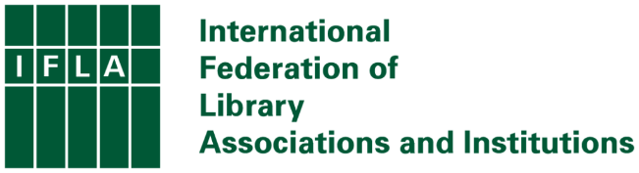

IFLA and Charity Status – Background Briefing

At its meeting on 15-17 April 2024, the IFLA Governing Board agreed to propose, at our upcoming General Assembly on 20 June 2024, the necessary changes to our Statutes to enable IFLA to formally apply for ANBI status under Dutch law. Acquiring ANBI status would mean that IFLA is more explicitly focused on public benefit and is the Dutch equivalent of a charity.

This briefing provides background to this process, ahead of the publication of the formal convening notice with the text of the amendments. In addition to this briefing and information shared with the convening notice, we will also hold online meetings to hear questions and provide any further details that our members need in deciding how to vote.

The IFLA we want
As part of our broader approach to enhancing IFLA’s sustainability and strong relationships with members, volunteers and partners, we want to ensure that our Federation is attractive and easily understood by all. In particular, we want to be able to work better with other organisations, and so create new opportunities for our members and volunteers that are consistent with our wider mission and strategy.

To do this, we need to remove unnecessary barriers to forming partnerships– notably for funding – and ensure that we are held to and comply with the highest standards of transparency in our reporting.

The situation today
Unlike many other organisations working in the library space in the Netherlands, IFLA currently does not have charity status. This brings the risk of making IFLA a less attractive partner for funders because of the cost and potential uncertainty involved in ensuring compliance with relevant tax law.

Moreover, IFLA’s current structure with a separate foundation (Stichting IFLA Foundation) is complicated and makes transparency more difficult. This situation is suboptimal for our members, volunteers and partners alike.

The legal requirements
Before IFLA can formally apply for ANBI status, we need to make a number of small changes to our Statutes in order to comply with Dutch law. We need to:
- ensure consistency in the definition of our missions as a Federation to ensure that we highlight our role in representing the interests of members, the wider library field, and the communities we serve;
- make clear that if ever IFLA were to close, any remaining resources would go to another ANBI organisation or foreign institution with a similar mission
- introduce formal protections to prevent any one individual – whether on the Governing Board or within the Executive - from having control over IFLA’s resources

Members will be asked to approve these changes at the General Assembly on 20 June 2024. Their agreement (2/3 of the votes, using weightings) is necessary. As such, the decision to transition or not to charitable status is in the hands of our Members.

The difference you will see
In the short term, you are unlikely to see much change. The transition to charity status has no impact on our governance structures, and so our members and volunteers will continue to have the same roles and rights as before. There are no greater reporting requirements on our volunteers or members, while IFLA as a whole has already adopted the higher standards of financial reporting required for charities in the Netherlands.

ANBI status also requires Governing Board members and the Executive to be persons of integrity and, in advance of the next elections, we will review the Code of Ethics and Conduct to ensure compliance and incorporate any new requirements into the election process.

In the longer term, we hope that the transition will mean that we can – working within the context of our missions and strategy – form new connections which create opportunities for members and volunteers, as well as ensuring IFLA’s own longer term sustainability.

The timeline
- 15 April: IFLA Governing Board approves proposal to the General Assembly to update IFLA’s Statutes
- w/c 22 April: publication of this briefing
- 22 May : Publication of formal convening notice with the text of amendments
- Late May/Early June: consultation sessions with Members to discussion questions around the transition to ANBI status
- 27 May: Voting on the amendments (and other motions) opens
- 20 June: General Assembly, final vote
- After 20 June: If the General Assembly agrees, the Governing Board will register the revised Statutes with the Dutch Chamber of Commerce and formally apply to the Dutch authorities for IFLA as a charity

