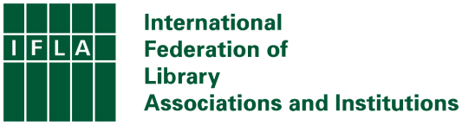
IFLA Statement on Universal Access to Healthcare Information as a Human Right

The importance of access to reliable, accurate, timely, understandable and actionable healthcare information has never been as clear as since the outbreak of the Covid 19 pandemic. In a time of crisis, the quality and speed of the healthcare information that people receive can determine if they survive. The pandemic also shone a light on another global crisis: inequality in the provision of reliable healthcare information, as highlighted by the Cochrane Call. This represents a challenge not just to health responses in times of crisis, but also to the achievement of health and wellbeing for all, as targeted by SDG3.

IFLA believes in and endorses a fundamental human right to reliable healthcare information, as is implicit in the Universal Declaration of Human Rights. We believe that this right is cumulatively guaranteed:
- by Article 19 of the Declaration, which asserts the right of people to receive and impart information without interference,
- by Article 25, which guarantees the right to a standard of living to maintain health, of which access to healthcare information is recognized as a determinant, and
- by Article 27, which promises the right to share in the benefits of scientific advancement.

Through the Declaration and subsequent texts, the governments of the world have recognized that access to healthcare information is essential for the delivery of the right to health, and agreed that each and every person has the right to information that is as up-to-date, credible, and accurate as possible, based on the results of scientific progress, as a means of living as healthy a life as they are capable of having.

Yet this is far from the case for all. Universal access requires investment in production of reliable, accurate and verifiable information that is relevant for all, in a form and language that makes it understandable. It also needs favourable legal settings and social norms, information dissemination infrastructures that reach all members of society, health literacy skills in the population, and a strong body of information professionals and institutions. These in turn depend on advocacy both within communities and towards decision-makers.

IFLA underlines its own commitment to supporting universal access to reliable healthcare information as a human right and reiterates the messages in its own Statement on Open Access. IFLA furthermore:

- Urges its own members and the wider library field:
  - To strive as far as possible towards the attainment of universal access to health information, both in their practice and their advocacy in communities.
- Calls for governments at all levels:
  - to recognise explicitly the right to healthcare information in national and international law.
  - to ensure that laws and regulations favour the right to healthcare information.
  - to support the development of health information that is relevant for all, in languages and formats that enable understanding and application.
  - to make the necessary investments – both domestically and beyond through development spending – to ensure a strong, effective, and inclusive infrastructure for healthcare information dissemination and application everywhere.
  - to enable libraries and other community organisations to support the delivery of the right to healthcare information, and support collaboration between these and healthcare organisations to ensure the optimum and sustainable provision of authoritative, credible, up-to-date and accurate information.

Statement prepared by the IFLA Evidence for Global and Disaster Health Special Interest Group and Health and Bioscience Libraries Sections, and approved by the IFLA Governing Board on 17 April 2024.

