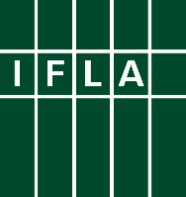
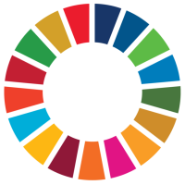
Libraries Engaged in VNRs
Part 8 Prepare for the High-Level Political Forum

Voluntary National Reviews (VNRs) can be a great way for libraries to engage in discussions around the implementation of the Sustainable Development Goals (SDGs), and to be recognised for their contributions. This series offers ideas for key actions libraries and library associations can take to get involved.

The eighth step towards successful engagement in a Voluntary National Review (VNR) is to prepare for the High-Level Political Forum at which Reviews will be presented. This will take place on 8-18 July 2024 in New York, with VNRs presented on 15-17 July.

On those days, Member States will present their reviews, either on their own (in the case of first-timers) or as part of a panel. Key messages (and full reports, most of the time) will be shared in advance – see this page, and filter the list by “2024” and “Voluntary National Reviews”). When you then click on the name of your country, you will be taken to a page showing these messages, as well as giving contact details and other useful background.

It will be useful to take a little time to read what your government has submitted, and to see how library priorities – and of course your own inputs – have been reflected. It is unlikely that libraries will be mentioned explicitly in the key points (although this should be a long-term goal!), but key themes such as education, literacy, culture, research, social cohesion and civic participation are all relevant areas. However, in 2023, for the first time, more than half of VNRs referenced libraries – see our analysis.

First of all, you should try to find points where you can agree with the assessment the government has made and congratulate them on these either through direct contacts (e-mail or otherwise) or publicly. Especially if they have mentioned libraries, you should thank them for this. The team who has produced this may well continue to work on the SDGs, and it will be good to reinforce your contacts with them for the future.

Secondly, you should also look out for things you would want to change or add. In previous parts of this series, you have developed key messages and supporting arguments, data and stories. You can either highlight these (in a constructive way) on social media, or work through IFLA to help ensure that your concerns are reflected in the statements that will be made by the NGO Major Group during the High Level Political Forum itself. IFLA will reach out to share possibilities to be part of drafting teams.

These points can also form the basis for exploring partnerships going forwards – how can you work together with governments and others in order to

Finally, IFLA will be sharing suggestions for letters that you can send to your governments in advance of the High-Level Political Forum, in order to ensure that the role of libraries is properly recognised in discussions.

Good luck!

